INDIAN INDUSTRY

O Current Trend in Industrial Sector O Purchasing Managers' Index O Evolution of Industrial Policies Prior to 1991 O Industrial Sickness
O Industrial Policy Resolution of 1948 (IPR-1948) O Remedial measures undertaken in the past

O Industrial Policy Resolution of 1956 (IPR-1956) ”
O Industrial Policy Statement of 1969
Board of Industrial and Financial
Reconstruction

O Industrial Policy Statement of 1973 O Industrial Policy Statement of 1977 O Industrial Policy Statement of 1980
O The Companies (Amendment) Act, 2019 O National Company Law Tribunal
O Corporate Social Responsibility (CSR)
O Recent Reforms in Industrial Labour Laws

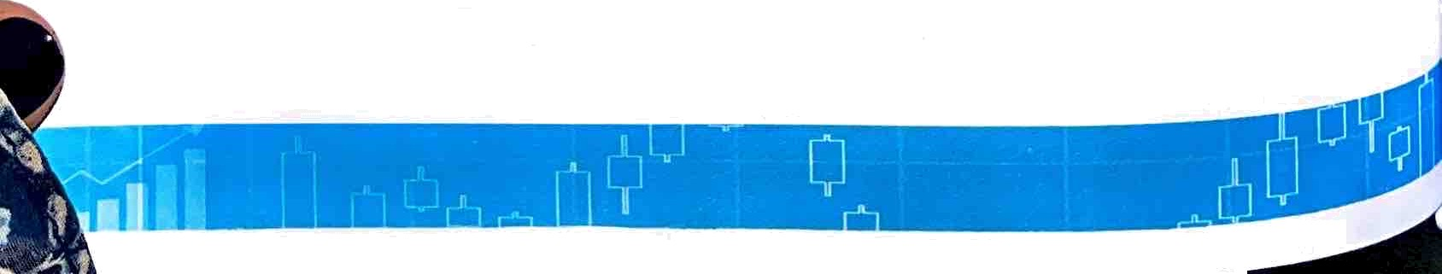
O New Industrial Policy 1991 O National Investment and Manufacturing O Public Sector Undertakings Zone
O Policy of Navratnas O Special Economic Zones (SEZs) in lndid
O Policy of Miniratnas O Ease of Doing Business Report
Policy of MaharatrlaS O Make in India
O Financial Autonomy to Maharatna CPSEs o Start-up India
0 Performance of CPSEs O Stand-up India
U Tools to measure performance of Industries o other Recent Reforms by Governmentin U Index of Industrial Production (IIP) Industrial Sector
U Index of Eight Core Industries U Champion Sectors in India Annual Survey of Industries O Industry 4.0 and India

Indian lndustry

Indian economy is divided
Îllto three major sectors, i.e. the primary
sector (agriculture), secondary

sator(manufacturing and industry) and tertiary sector (services).
Industrial sector usually collects raw material from the primary sector and then produces consumer goOds, Capital goods, etc. Industrial sector is the second major contributor of GDP in the economy among the three sectors. Therefore, the government gives a good amount of focus on the development of industrialsector.

O Industrial sector c‹intributed 31 per cent of the GDP of our country in 2021—22. In 1950—51, it was just around 15 per cent. It is employing over 12.1 crore people.
O As per the recent Economic Survey 2022—23, industrial sector's overall contribution in gross value added (GVA) is estimated to be 30.0 per cent in FY 2022—23.
O Thus, it can be interpreted that after Independence, it initially showed a rising trend towards its contribution/share in GDP. However, with the rapidly increasing share of service sector, the share of industry in overall GDP started showing a t1uctii:iting trend in recent years.

Share of industrial sector in GVA 29.6% | 26.7 | 25.99 | 30.0%

âliijor sectoral classilic.iti‹›n under industrial sector:
- Mining and quarrying
- Manufacturing
- Electricity, gas, water supply and other utility services
- Consmiction
0 Among above four, mite Inf.4cltiring st'ct‹›r has the major contribution towards GDP.

Industrial Policy Resolution of 1948 (IPR-1948)

Lnder this poJ1cy.
Pattern. The m J r
system Of lTlÎX8d econom› was introduced in India taking the society on a socialistic
I’e•itures ot IPR-1948 were:

Only two pages were converted.
Please Sign Up to convert the full document.

www.freepdfconvert.com/membership

