TL;DR
Gantt chart
Resources
Helpful phrases & strategies to participate in/lead productive meetings more confidently

So when you are reporting about projects or daily tasks, do you ever have to mention problems, things that block your road and don't let you move forward?
Would love to hear from you and let's get more confidence saying this in meetings in English.

&
So, how's it going? Let's get some practise giving progress updates! Try one of the 3 formats from Lessons 1 and 2:
1 Answer the 3 questions:
- What have you completed?
- What are you working on?
- What's next?
2 One Win, One Lesson: what is one thing you've achieved and one challenge you faced that taught you something
3. Share a story about a longer-term project with some background, a discovery, and a recommendation (all very brief!)

KA An
1.
- I have completed a project with colleagues from the Product team in my company. We had to integrate a tool into you system. That was nothing than a success.
- I'm working on launching our service in Germany. I have to ensure that we're aligned with the payment provider we're going to use in Germany.
- The next for me is to establish a new German team and I'm actively recruiting people for the German role.
2. Achievement - I've managed to create a bonus scheme for a new task, this is additional incentive for our employees to be even more productive. It's not personal, but team achievement.
Challenge - I'm always trying to do the work on my own, I rarely delegate part of my assigned tasks to my colleagues or direct reports. I had to execute 2 important tasks (technical and procedural) and one of them was delayed, because I didn't delegate properly... That was the lesson I taught.

Tanya Kirilova
Wow, KA An, you've been busy! Congratulations on adding a new country to your region. Two very impressive updates with all the elements that make them informative, clear and well-organised. Structure, tenses, range of vocabulary and structures, all really good.
Here are some minor things you can change.
First piece: 'it was nothing but...' or 'nothing short of a... ', though here the best choice probably is 'it was a major success';
'the next' needs a noun = My next project/ The next task/ goal for me is...
Second piece:
Articles in front of countable nouns - an additional incentive; not a personal but a team achievement;
the lesson I learned = it has taught me a lesson
Thanks for your active engagement with the course!
I look forward to our live Q&A tomorrow.

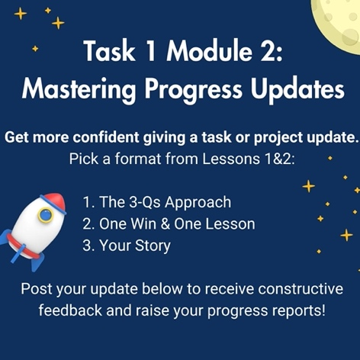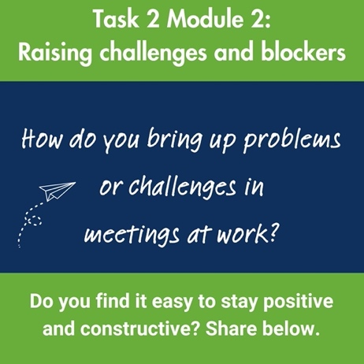

"Could you really not just put this in an email?"
Thomas Benjamin Wild Esq's question is probably something we've all thought at some point or other, sitting at a pointless meeting that could have easily been an e-mail.
Have you ever sat through a meeting and thought, "This could have been an email"?
What makes a meeting truly necessary and productive?
Share your thoughts below, and let's discover together how to make every meeting count. Remember, the goal is not to eliminate meetings but to ensure they're impactful, engaging, and, most importantly, necessary. #MeetingsVsEmails #ProductiveMeetings

Module 2
Progress Meetings and Status Updates

Week 2 Lesson 1 Overview and Useful Language for Progress Meetings

Good morning, my dear business people!
Finally, I am posting 1 out of 3 lesson on Progress and Status Update Meetings. Tried a different technique for recording the video - do let me know if it's more or less helpful for you.
So, Progress and Status Update Meetings. Lesson 1 deals with some terms, abbreviations, general tips on preparation and useful language.
I'll post some tasks separately, but please let me know what your main takeaway is.

&
Types of Progress Meetings
- Project Monthly/Weekly Meetings
- Status Updates
- Daily Meetings = Stand-ups in tech
- All Hands or All Saff Meetings
- One Win, One Lesson
- Brag and Complain

Decoding abbreviations:
- AOB = Any other business (the wild card on the agenda = the item on the agenda that is open for discussion & team members can add their points to the meeting)
(in card games: a card that has no value of its own and takes the value of any card that the player chooses)
- COB = Close of business & COP = Close of play (suggest that certain tasks need to be done before the end of the working day
- EOD Reports = End of day Reports (= daily debriefs that make sure the whole team is on the same page as the day closes)
- TL;DR = Too long; didn’t read (= a quick way to get to the heart of the matter – summarising a lengthy discussion)
[TL;DR] is a Natural Language Processing(NLP) text summarizer. It uses the extractive method, meaning it will use sentences from the text for the summary.
tl;dr AI is your smart reading companion, instantly summarizing any article on the web to save you time and help you stay informed.

tl;dr AI
gettldr.app
https://gettldr.app

Getting Ready for Meetings & Sharing Key Info in Advance
- Use Project Management Software to track progress
- Share the agenda & the format

Asking Yourself the Right Questions
- What updates do I need to provide?
- What ideas or questions do I want to bring up?
- What challenges am I facing?
- Who do I need to thank & acknowledge? (= give credit to others for the way they have helped with the tasks)

Useful Idioms
meet the deadline / make/miss/extend the deadline
stay on track (with the project) (= reach a goal on time
be behind schedule (for sth) / be ahead of schedule

Useful Collocations
give a status update (to sb regarding sth)
resolve an issue = remove a blocker
face a challenge

Others:
development/design phase
initial phase of the market research
alpha-test sth /ˈælfə test/ (of a company) to test a new product that they are developing
start the beta testing phase /ˈbiːtə test//ˈbeɪtə test/ (= to test a new product developed by another company)
finalize the design

Grammar for Meetings
- Present Continuous for current actions
“What are you working on at the moment?”
- Present Perfect for actions we have just finished
“I have completed the initial phase of the market research.”
- “Be going to” for future plans
“We are going to start the beta testing phase next week.
- Using “by” for deadlines: complete the client report by Thursday
“We need to complete the client report by Friday to review it in our meeting.”
- First Conditional for planning
“We can stay on track if we finalize the design by next week.”

Recap:
- Learn as much about the meeting in advance
- Demystify terms & abbreviations
- Think about your contributions
- Prepare the necessary language

Week 2 Lesson 2 Preparing as a Participant (in Progress Meetings)
Dear Business English friends,
Lesson 2 of our Progress Meetings Module is here! This lesson is tailored for anyone regularly updating their teams, team leaders, and project stakeholders.
It's packed with practical skills and strategies designed, along with Lesson 1, to help you prepare more easily and show up with confidence in international work meetings.
I’d love to hear which parts you find most useful and how you plan to apply them. Your insights could spark more thoughts and curiosity in someone else in our community!
On its way to you shortly will be Lesson 3, where we’ll turn our attention to those leading the meetings.
Let's get some of that confidence!
Questions, thoughts, comments, please share.

How to give an Update 1
The Three Questions Structure:
- What have you completed?
- What are you working on?
- What’s next?
How to give an Update 2
Share a Story, Not Just Facts
- Context/background to your story
- Trend/Challenges
- Lesson learned or…
What’s next?

If sth’s in your way, just say it
“I’m stuck on… (achieving this)”
“I’m having trouble with… (this software)”
“I need help with…”
“We’re currently facing a challenge with our software upgrade.”

Specify the Help You Need
“To resolve this, we need additional IT support or perhaps exploring alternative software solutions, different resources, etc.”

Stay Positive, Acknowledge Others
Show that you’re looking for solutions, not just pointing out problems.
“I’m confident we can overcome this if we…” & make a suggestion.
Thanks for addressing that problem.”

Presenting Mixed Results
- Focus on Lessons Learnt
“We faced [issue], but we got better at…
by [lesson learned],”that problem”
Transform setbacks into valuable learning experiences & remain positive as you move forward on the project.
- Frame Requests/Needs Positively
“To reach out next milestone, we need more info/resources/ additional support for the front-end development team. This will help us achieve our goal. Can we discuss how to make this happen?”
- Celebrate Every Success
Acknowledge all positive outcomes, encourage the team & it will boost morale.
“Despite the challenges, we successfully launched [project/component], thanks to our collective effort.”

Recap:
- How to structure your update
- Bringing up roadblocks
- Balancing realism& optimism
Present mixed results in a way that keeps the team engaged, motivated & focused on continuous improvement.

Week 2 Lesson 3 Preparing as a leader
Dear Business English people,
Here comes the final Lesson 3 for this week.
It's aimed at leaders who manage progress /update meetings.
Let's discuss your main takeaways and questions.
I look forward to your views, thoughts and comments.
Have a great day!
Tanya

Create an atmosphere of adaptability, ownership and accountability.
The Players & the Goal
- I know most of you, but I see a few unfamiliar faces. Before we start, let’s do a quick round of introdusctions.
- As a quick reminder, our goal for this meeting today is [insert purpose].
- By the end of this meeting today, we should have a decision on [insert purpose/outcome].

Asking for Updates
- Respect & Focus
“Could you share the latest progress on [specific task]?”
“Are there any obstacles we need to clear to move forward with [specific task]?”
- Create an Encouraging Environment
If the goal of the meeting is to have team members willingly share their updates, it is important to foster open communication & create an atmosphere where team members would be happy to share realistically where they’re at.
“I’d like to hear about your recent work & how I can assist. Shall we go round the table?”

The team leader might share personal challenges & the way s/he overcame those challenges. This might encourage openness.
“I faced a hurdle with [issue] this week & tackled it by [solution]. Have any of you encountered something similar?”
- Everyone is (Seen &) Heard
“Alex, we’d appreciate your insights on [task].”
“That’s a fantastic/great point, Sam. It gives us a new perspective. Thank you very much for contributing.”

Navigating Deadlines & Milestones
People need reminders. They need to see where they are within the project within the team.
- Use visual aids to outline key dates.
- Schedule regular check-ins to focus on deadlines
- Ask “Are we on track to meet our next milestone?”

Useful:
- Gantt chart /ˈɡænt tʃɑːt/ (business) = a chart used for managing the tasks involved in a project that shows when each stage should start and end and compares the amount of work done with the amount planned
- Regular check-ins (focusing on deadlines)
- Showing flexibility when plans need to be adapted is invaluable.
Adapt plans as needed: “Given our status, what adjustments can we make to ensure we meet our milestone?”

Ensuring On-Track Progress
- Conduct progress reviews to discuss achievements and challenges.
- Hold one-on-one meetings for individual contributions.
- End discussion with “How can I support you?”
View challenges as opportunities for innovation.

Encouraging Solutions & Adaptability
- Foster solution-oriented conversations with the phrase:
“Let’s explore our options for overcoming this challenge.”
- & here’s a useful phrase:
“What have you tried doing? [the main thing]
It means that sth else is the main objective but we approach it in different ways.
- Have you tried doing sth?
“There’s a bug, a problem in the system. Have you tried updating/uploading the software?”
“Have you tried talking to someone else from the team?”

Action & Accountability Closure
- Recap of Actions: clear, actionable tasks assigned.
- Ownership: clarity about everyone’s responsibilities.
- Accountability: systems in place to ensure timely completion.
At the end of the meeting it’s vital for everybody to know what needs to be done, who will do it & how, so that everyone leaves the meeting knowing exactly what they’re supposed to do & when.
A good proactive leader needs to ensure that the meeting ends with a definitive summary, next steps, incl. action items with clear tasks assigned
Accountability framework, where procedures for monitoring meeting deadlines are discussed. This might include regular check-ins, progress reports, or specific benchmarks for project milestones.

Recap:
- Clearly requesting updates
- Fostering open communication
- Engaging all participants
- Effectively managing time and progress
Team leaders can create an environment where meetings are productive, positive, inclusive, and good for the team’s morale.

&
Hi Copilot! Could you please share ideas what makes a meeting truly necessary and productive instead of putting what it’s about in an email?
Define the meeting objectives + Create an agenda (outline the topics, the time allocated for each, and the expected/desired outcomes) + pre-work or materials participants need to prepare or review before the meeting
&
create a safe space for collaboration in a meeting.
&
assign roles to some of the attendees, such as a facilitator, a note-taker, a timekeeper, and a presenter, to ensure the meeting runs smoothly and efficiently.
+
follow the agenda and respect the time limit.
+
keep the conversation focused and relevant
+
end with a summary of the main points, decisions, and outcomes
+
assign action items to the responsible parties, along with deadlines and follow-up steps.
+
send a meeting recap to the attendees and other key stakeholders, highlighting the key takeaways, actions, and next steps.
https://www.mckinsey.com/featured-insights/mckinsey-explainers/what-is-an-effective-meeting
https://www.scienceofpeople.com/run-a-meeting/
https://rize.io/blog/meeting-productivity

